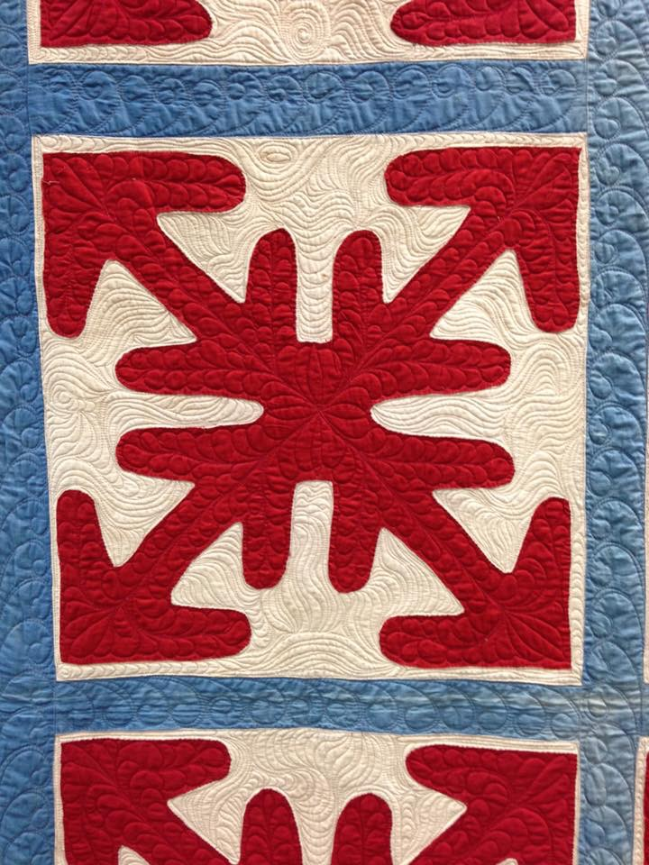

Old Glory Quilt Exhibit: curated by Mary Kerr
Press release

We are excited to announce the upcoming debut of a traveling quilt exhibit designed to benefit the Quilts of Valor program.

Old Glory was born when red white and blue vintage quilt tops were finished by long arm quilters who share a military connection. The quilters received the top, backing and the instructions, “quilt as desired”. They donated their time and talent. We chose to work with “forgotten” tops - the ones that were damaged, unfinished, ill made or unremarkable. These tops were not destined to be completed, enjoyed or treasured. What we now share is pure magic!

The exhibit was created to promote the Quilts of Valor program. We choose to focus on our patriotic heritage and further serve the military family that we have been fortunate to be a part of. These quilts will debut at the 2017 Quilts of Valor show and then travel as a collection for 18-24 months. When they are done traveling the quilts will be auctioned to raise funds for Quilts of Valor.

Mary Kerr
mary@marywkerr.com
www.marywkerr.com

Many thanks to Mary Kerr for the donation of the Old Glory Quilt Exhibit to benefit Quilts of Valor®Foundation. These quilts are not and were never intended to be Quilts of Valor but are a wonderful exhibit of patriotic vintage quilts. They will be on exhibit at the Annual Conference of QOVF, June 5-6, 2017 at the Eldorado Hotel, Colorado Springs, CO.

